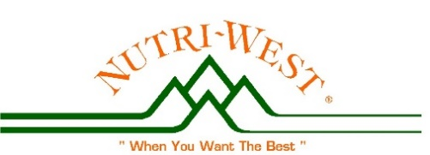
NUTRI-WEST and
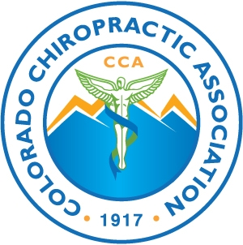
the CCA PRESENT:

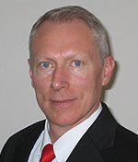
“Chiropractic Nutrition and Adapting to the Ever Changing Environment” **

with Dan Murphy, DC

Mar 18 & 19 12 CEs CO (ask about your state)
Dan Murphy, DC

Dan Murphy is back for a full weekend seminar on adapting to our changing environment! Challenging times have presented reasons for challenging our status quo protocols - We need to be on top of the latest research on chiropractic nutrition to deal with the enormous amount of information we get exposed to on a daily basis.

The best way to do that is to listen to the master: Dr. Dan has always had his finger on the pulse for recent research in chiropractic, recent research in nutrition, and recent research that affects both!

What’s going on? What’s changed? What works? What doesn’t?
The one and only Dan Murphy, DC is back for his first 12 hr. CO Nutri-West seminar in two years!

Co-sponsored by the CCA. This seminar is LIVE only and is not telecast.

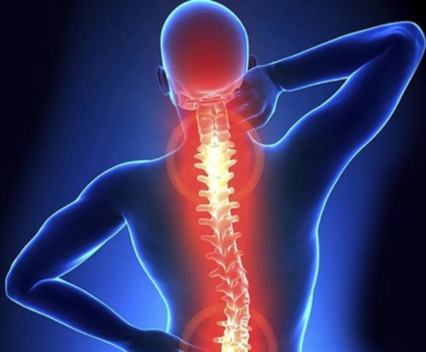

+

Don’t miss the latest and greatest in the fields of chiropractic, nutrition, and how it all helps in today’s world of constant health challenges!

Knowledge is Power
Power –> Protocols for efficacy
Learn new protocols with Dr. Dan!
Updates will be posted on the Nutri-West website www.NutriWest.com
Please call 800-443-3333 for your professional access Code.
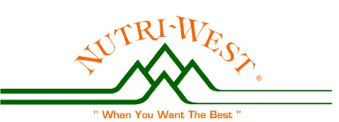
Date/Times: Sat. Mar 18, 2023 9:00 am – 6:00 pm and Sun Mar 19, 2023 8:00 am –12:00 noon
Cost: $295.00 Professional or $150.00 Students
Location: Marriott Denver South; 10345 Park Meadows Dr., Lone Tree, CO 80124

Register: CCA website www.coloradochiropractic.org
For more info: Dr. Lynn Toohey
866-271-8888 /720-470-1934
Email: drtoohey@nutri-west.net

